Decision Making Machine

Triggers: Any information that your senses gather. These include almost everything in the world! These sights, sounds, smells and events will have personal values based on your experiences with them.

Obsessive Thinking: Emotional and chemical driven thought; these include much of the automatic processing, like blinking, releasing endorphins and digestion. Closed to new data. These are powerful, fast, efficient, but do not represent our intellect.

Process Thinking: Careful, well-planned thinking that either programs or reprograms behaviors. This takes time, energy and is always open to new data.

Compulsive Behavior: Directly follow obsessions. These work with emotions and reward systems. These include instincts and trained reactions.

Planned Behavior: The result of strategy. These can disregard emotions and old programing, if they get in the way of logic.

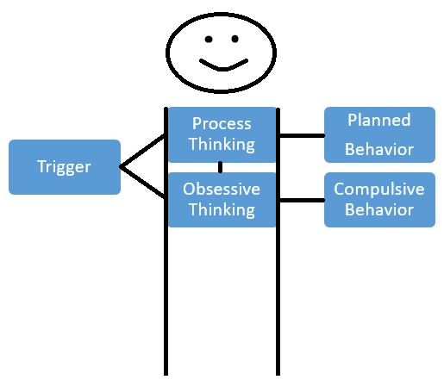

Triggers are products of our environment and inform us of the world around us. We analyze this data to generate favorable behaviors. We sometimes develop systematic errors in the way we interpret data. Understanding this machine can help focus attention to the areas that need repair or change. We practice with identifying triggers and assign values to these, so that we become more mindful of our environment and how we interact with it. Over time we develop an understanding of our obsessions and can limit the impulsive actions and increase good strategy.

Decision Making Skills

Measuring Behavior:

The measure of behavior is its effect on survival. High quality behaviors are those that secure, enhance or directly result in survival. Low quality behaviors place an organism at risk, reduce security or cause harm. Scoring behaviors on a scale (see below) can help bring awareness to patterns and old behaviors that no longer or never did serve well. Targeting high quality behaviors with consistency is the foundation of mental health.

0 . . . . 5 . . . . 10

Skill Levels:

Mal-adaptive Skills: Will always cause more harm than good.

Neutral Skills: Will cause neither harm nor growth.

Healthy Skills: Will always promote healthy development.

Coping skills are the tools that get us through crises; some are better than others are, some take years to learn and some come by way of instinct. The quality of a coping skill should consider the scope of benefit. Skills that change over time and focus on long-term benefit, are more complex and are often healthier than the ones targeting an immediate need. Only by constantly assessing our skills can we ensure that we are using the most appropriate coping mechanisms.

Destination/Purpose

Healthy skills and constantly making high quality decisions will generate a state of perpetual awe. By constantly using healthy skills, we begin to demand truth over comfort while becoming eager to learn more. Radical acceptance gives us a focused zeal for discovery. Increasingly, new concepts and skills become part of our survival. A lack of expectation brings clarity of vision, which helps us better harmonize with the world around us. Relieved of unnecessary stress and expectation, we reveal our individual role as only we can see it.

